**For the following questions please provide me with your answer to each question. You may not work with anyone else on this exam.**

1. Below is an MTMM matrix representing data from a managerial assessment center (AC). Participants were rated on four dimensions (oral communication, team building, innovation, & stress tolerance) via three exercises (i.e., in-basket, allocation, & management problems). Please make the following calculations noted below. (20 points)
2. What is the degree of convergence (C)?
3. What is the degree of discrimination (D1 and D2)?
4. What is the degree of method variance (MV)?
5. Overall, does this AC seem to demonstrate appropriate construct-related validity?

|  |  |  |  |  |  |  |  |  |  |  |  |  |  |  |
| --- | --- | --- | --- | --- | --- | --- | --- | --- | --- | --- | --- | --- | --- | --- |
|  |  |  | 1 | 2 | 3 | 4 | 5 | 6 | 7 | 8 | 9 | 10 | 11 | 12 |
| 1 | Oral Communication | In-basket Exercise | 1.00 |  |  |  |  |  |  |  |  |  |  |  |
| 2 | Team Building | In-basket Exercise | 0.43 | 1.00 |  |  |  |  |  |  |  |  |  |  |
| 3 | Innovation | In-basket Exercise | 0.38 | 0.48 | 1.00 |  |  |  |  |  |  |  |  |  |
| 4 | Stress Tolerance | In-basket Exercise | 0.31 | 0.22 | 0.30 | 1.00 |  |  |  |  |  |  |  |  |
| 5 | Oral Communication | Allocation Exercise | 0.63 | 0.40 | 0.39 | 0.27 | 1.00 |  |  |  |  |  |  |  |
| 6 | Team Building | Allocation Exercise | 0.37 | 0.55 | 0.42 | 0.22 | 0.51 | 1.00 |  |  |  |  |  |  |
| 7 | Innovation | Allocation Exercise | 0.30 | 0.40 | 0.53 | 0.17 | 0.45 | 0.51 | 1.00 |  |  |  |  |  |
| 8 | Stress Tolerance | Allocation Exercise | 0.32 | 0.20 | 0.24 | 0.72 | 0.38 | 0.28 | 0.24 | 1.00 |  |  |  |  |
| 9 | Oral Communication | Management Problems | 0.54 | 0.38 | 0.42 | 0.24 | 0.68 | 0.48 | 0.45 | 0.31 | 1.00 |  |  |  |
| 10 | Team Building | Management Problems | 0.36 | 0.44 | 0.44 | 0.22 | 0.49 | 0.62 | 0.41 | 0.28 | 0.60 | 1.00 |  |  |
| 11 | Innovation | Management Problems | 0.31 | 0.26 | 0.50 | 0.23 | 0.39 | 0.41 | 0.49 | 0.27 | 0.49 | 0.51 | 1.00 |  |
| 12 | Stress Tolerance | Management Problems | 0.34 | 0.21 | 0.28 | 0.70 | 0.34 | 0.28 | 0.22 | 0.80 | 0.38 | 0.32 | 0.30 | 1.00 |

This is a 4-trait, 4-method matrix. SDDE > DDSE > DDDE

* 1. C1 =

1. The annotated output below is from a G-theory analysis of third grade students. The ratings are in relation to the aggressive behavior of these students. Each of the students (P) are rated by multiple teachers (F1) with multiple observations (F2). (25 points)
   1. Explain to me what each of the seven calculated facets are indicating (i.e., P, F1, F2, P*F1, P*F2, F1*F2, & P*F1*F2).
   2. Overall, what do these results suggest regarding the functioning of this behavioral rating system?
   3. What changes could be made in regard to the number of teachers rating to improve Phi to an acceptable level (.70)?
   4. What changes could be made in regard to the number of observation to improve Phi to an acceptable level (.70)?
   5. What is the best combination improvement to get Phi to an acceptable level?

GENERALIZABILITY THEORY ANALYSES:

Design Type 3: two-facet fully-crossed design, as in P * F1 * F2

Number of persons/objects ('P'):

10

Number of levels for Facet 1 ('F1'):

4

Number of levels for Facet 2 ('F2'):

2

ANOVA Table:

df SS MS Variance Proport.

P 9.000 76.813 8.535 .781 .260

F1 3.000 31.938 10.646 .297 .099

F2 1.000 6.613 6.613 .071 .024

P*F1 27.000 56.938 2.109 .561 .187

P*F2 9.000 10.513 1.168 .045 .015

F1*F2 3.000 10.738 3.579 .259 .086

P*F1*F2 27.000 26.638 .987 .987 .329

Error Variances:

Relative Absolute

.286 .429

G-coefficients:

G Phi

.732 .646

D-Study:

Entered D-Study values for Facet 1:

3 4 5 6 7

Entered D-Study values for Facet 2:

1 2 3 4 5

In the D-study results below, the levels of Facet 1 appear in

the first column, and the levels of Facet 2 appear in the first row.

D-Study G Coefficients

.000 1.000 2.000 3.000 4.000 5.000

3.000 .582 .676 .715 .736 .749

4.000 .644 .732 .767 .785 .797

5.000 .687 .770 .802 .819 .829

6.000 .720 .797 .827 .842 .852

7.000 .745 .818 .846 .860 .869

D-Study Phi Coefficients

.000 1.000 2.000 3.000 4.000 5.000

3.000 .488 .586 .627 .651 .665

4.000 .548 .646 .686 .708 .722

5.000 .592 .688 .727 .748 .761

6.000 .625 .719 .757 .777 .790

7.000 .652 .743 .779 .799 .811

1. The figures below are from an item response analysis of a test of general mental ability (i.e., *g* or IQ). The first figure is the information curve for the entire test and the second figure includes the item characteristic curves for three items (i.e., A, B, & C). Looking at the first figure, what can you tell me about the information provided by this test? Compare and contrast the three different items. What can you tell me about each of those items? (25 points)

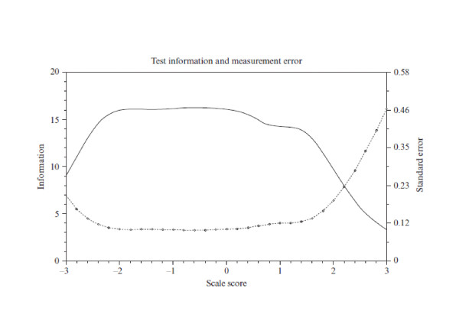

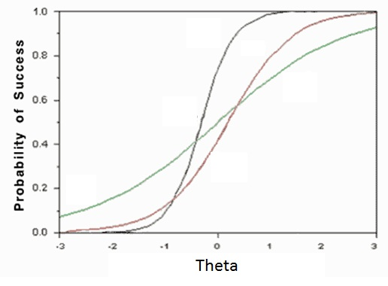

B

C

A